10.7 Geotechnical strata
10.7.1 Soil profiles
The soil profile along the entire dyke cross section is given in Figure 10.7.1. The profiles obtained based on geotechnical investigation is detailed below
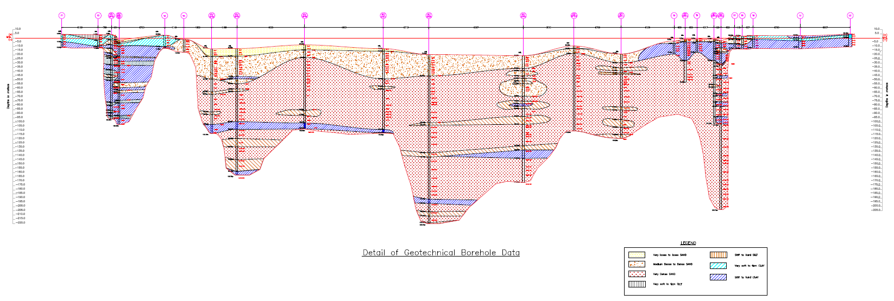
Figure 10.7.1 : Bathymetry and geotechnical Profile of the dyke
(a) Longitudinal Profile
(1) Basic Characterization
Classification of soil samples collected from different depths of borehole was reported as per IS 1498 (1970). Grain size analysis carried out according to IS 2720 (Part 4) (1985) and Atterberg limits determined as per IS 2720 (Part 5) (1985) were incorporated to classify the soil according to the plasticity parameters.

Zone-1: Intertidal region at Bhavnagar (Boreholes T1, T2, T3, T4, GT-SPT1, GT-SPT2, GT-SPT3,)
Detailed site investigation was carried out over the total length of the intertidal region at Bhavnagar (referred to as Zone-1) to study the soil profile. A total of 7 boreholes in zone-1 were drilled as an integral part of the site investigation. The city of Bhavnagar lies to the west of this zone while this zone is bounded by Zone-2 on the east.
Laboratory tests were carried out on samples collected at different depths in boreholes T1, T2, GT-SPT2, GT-SPT3, T3, and T4. GT-SPT1 was employed exclusively for performing CPT. The boreholes T1, T2, T3, and T4 were drilled to a depth of about 15.50 m from EGL. Boreholes GT-SPT2, and GT-SPT3 extended to a depth of about 100 m with respect to the EGL. T1 was assumed as a benchmark and the location marked the beginning (0.00 m) of the horizontal scale in the profile diagram. The location of subsequent boreholes in all the zones was determined with respect to the corresponding distance from T1.

Borehole T1
Top 0.5 m depth of the borehole comprised of firm silty clay followed by layers of soft silty clay up to a depth of about 9.00 m from the EGL. Beyond this depth, the borehole comprised stiff silty clay strata.

Borehole T2
The top 6 m of the borehole was predominantly composed of very soft clayey silt. Thin patches of firm clayey silt layers were also encountered within this depth. This stratum was followed by a very soft silty clay layer over a depth of about 6-11 m from the EGL. The presence of very stiff sandy silty clay layer was noticed at the bottom of the borehole. The soil strata in boreholes T1 and T2 are shown in Figure 10.71.

Borehole GT-SPT2
Very soft to soft clayey silt of about 0.5 m thickness formed the topmost strata of the borehole. Layers of very soft to soft silty clay were observed between 0.5-6 m depth of the borehole. Layers of form clayey silt were noted between a depth of about 6-10 m from the EGL. Soil strata beyond this depth were predominantly very stiff to hard silty clay. Pockets of very stiff to hard clayey silt, sandy clayey silt, or sandy silt were noted in depth ranges of about 16-22 m, 25 m, 48 m, and 69 m from the EGL. Thick strata of very dense silty fine sand were noted between 27-36 m, 42-48 m, 51-54 m from the EGL. Pockets of very dense silty sand layers were encountered at various depths including the bottom of the borehole. Very thin strata of well-cemented sand and gravel were also encountered at the bottom.

Borehole GT-SPT3
Loose to medium dense silty fine sand constituted the top 3.5 m of soil stratum. Soil strata predominantly comprised very stiff to hard silty clay. Layers of medium dense to dense silty sand of considerable thickness were encountered between a depth of around 24 m and 30 m from the EGL. Pockets of medium dense to dense silty fine sand were also observed at various depths in the borehole. The soil strata in boreholes GT-SPT2 and GT-SPT3 are shown in Figure 10.7.2.

(a) | (b)
Figure. 10.7.2 Soil strata in boreholes (a) Legends for different soil classification (b) Soil strata in boreholes T1 and T2

Borehole T3
Firm to soft silty clay strata composed the top 0.5 m depth of borehole. Very soft to soft silty clay soil constituted the soil strata in the borehole between a depth of around 0.5 m and 10 m from the EGL. The bottom layers were formed of firm to stiff silty clay.

Figure 10.7.3 Soil strata in boreholes GT-SPT2 and GT-SPT3

Borehole T4
Medium dense silty fine sand constituted a predominant depth of borehole. Layers of dense to very dense silty fine sand were encountered towards the bottom of the borehole. Figure 10.7.3 illustrates the soil strata in boreholes T3 and T4.

Figure 10.7.4 Soil strata in boreholes (a) T3 and (b) T4

Zone-2: Channel A in Gulf Region (Boreholes GT-SPT4, GT-SPT5, GT-SPT6, GT-SPT7)
Zone-2 lies entirely in the Gulf of Khambhat. Two boreholes GT-SPT4 and GT-SPT5 were drilled to a depth of about 100 m and 150 m respectively from the EGL. The seabed level (EGL) was encountered at a depth of about 12 m below MSL in this zone.

Borehole GT-SPT4
The soil strata in the borehole comprised predominantly silty fine sand that varied from medium dense to very dense states. Loose fine sand was encountered in about top 7 m length of the borehole. Thin bands/layers of stiff to hard sandy silt were encountered at depths of about 50 m and 75 m with respect to the EGL. A layer of very stiff to hard silty clay was observed at the bottom of the borehole from a depth of about 90 m from the EGL.

Borehole GT-SPT5
Similar to GT-SPT4, about top 7.5 m length of the borehole is comprised of loose layers of silty fine sand. The soil strata were predominantly composed of medium dense to very dense silty fine sand with presence of few thin layers of very stiff to hard sandy silt and clayey silt strata at depths of about 48 m, 87 m, 110 m, and 135 m with respect to the EGL. Few pockets of stiff to hard silty clay with traces of gravel were encountered at depths of about 33 m and 57 m with respect to the EGL. The bottom of the borehole includes a stratum of hard silty clay at a depth of about 145 m with respect to the EGL. The sub-soil strata in Zone 2 as observed in boreholes GT-SPT4 and GT-SPT5 are shown in Figure 10.7.4.

Zone-3: Channel B in Gulf Region
Zone-3 is located in the Gulf of Khambhat. Two boreholes GT-SPT6 and GT-SPT7 were constructed in this zone to a depth of about 100 m from the EGL. The seabed level (EGL) as observed from these boreholes is located at a depth of about 8 m and 12.5 m from the MSL in GT-SPT6 and GT-SPT7 respectively.

Borehole GT-SPT6
Loose strata of silty fine sand were encountered in the top section of the borehole up to a depth of about 4.5 m with respect to the EGL. Presence of medium dense to dense layers of silty fine sand is noted spanning from a depth of about 4.5 m to 10.5 m with respect to the EGL. Soil strata beyond this depth to the bottom of the borehole mainly comprise very dense layers of silty fine sand. Pockets of firm to stiff silty clay layers are present at depths of about 33 m, 50 m and 70 m from the EGL. A thick layer of very stiff to hard layer of clayey silt is encountered between a depth of nearly 78-84 m with respect to the EGL. Layers of very stiff silty clay are present towards the bottom of the borehole at deeper depths ranging between 90 m and 100 m with respect to the EGL. Very thin strata of very dense well cemented gravel lie at the bottom of the borehole.

Borehole GT-SPT7
Loose to medium dense silty fine sand is present in the top 1-1.5 m of the borehole followed by layers of medium dense silty fine sand to a depth of about 30 m with respect to the EGL. Dense layers of silty fine sand are noted at depth of about 30-35 m with respect to the EGL. Soil strata in the borehole beyond this depth are mainly comprised of silty fine sand. Pockets of very stiff to hard silty clay were encountered at depths of about 51 m, 93 m, 96 m, and 98 m with respect to the EGL. Thin bands of very stiff to hard sandy silt and clayey silt are also present at depths nearly 45 m, 96.5 m, and 100 m with respect to the EGL. Sub-soil profile in Zone 3 is shown in Figure 10.7.5.
Figure 10.7.5 Sub-soil profile in Zone 2 (GT-SPT 4 and GT-SPT 5)

Figure 10.7.6 Sub-soil profile in Zone 3 as observed in (a) GT-SPT6 and (b) GT-SPT7

Zone-4: Channel C in Gulf Region (Boreholes GT-SPT8, GT-SPT9)
Zone-4 is located in the Gulf of Khambhat. Two boreholes GT-SPT8 and GT-SPT9 were drilled in this zone to a depth of about 200 m and 150 m from the EGL respectively. The seabed level (EGL) as observed from these boreholes is located at a depth of about 19.4 m and 20.9 m from the MSL in GT-SPT8 and GT-SPT9 respectively.

Borehole GT-SPT8
It is observed that layers of medium dense to dense fine silty sand form the top 5 m depth of the borehole. Beyond this depth, the soil strata are predominantly composed of dense layers of silty sand up to a depth of about 24 m with respect to the EGL. Layers of very dense medium to fine silty sand comprise the soil strata at a depth spanning between 24 m with respect to the EGL and the bottom of the borehole. Few pockets of hard clayey silt and sandy silt are present at greater depths of about 81 m, 102 m, 117 m, 192 m, and 200 m with respect to the EGL. Thin strata of very stiff to hard silty clay are observed at depths nearly 172 m and 187 m with respect to the EGL.

Borehole GT-SPT9
Layers of silty fine sand in medium dense state formed the top soil strata in the borehole up to a depth of about 24 m with respect to the EGL. Dense layers of silty fine sand are present between a depth of about 13.5 m and 20 m with respect to the EGL as well as between 24 m and 45 m with respect to the EGL. Between 45 m with respect to the EGL and the bottom of the borehole, the soil layer is predominantly formed of very dense layers of fine silty sand. Thin layers of stiff to hard sandy silt and clayey silt are present at about 0.2 m, 30 m, 45 m, 54 m, 60 m, 72 m, 78 m, 107 m from the EGL. Sub-soil profile in Zone 4 is shown in Figure 10.7.7.

Zone-5: Channel D in Gulf Region (Boreholes GT-SPT10, GT-SPT11)
Zone-5 is located in the Gulf of Khambhat closer to the east coast of the Gulf and preceding the Spillway zone. Two boreholes GT-SPT10 and GT-SPT11 were constructed in this zone to a depth of about 100 m from the EGL. The seabed level (EGL) as observed from these boreholes is located at a depth of about 9.2 m and 18.8 m from the MSL in GT-SPT10 and GT-SPT11 respectively.

Borehole GT-SPT10
Loose to medium dense layers of silty fine sand comprise the initial length of about 4.5 m from the EGL followed by dense strata of silty fine sand up to a depth of about 9 m with respect to the EGL in the borehole. Beyond this depth, soil strata predominantly comprised of very dense silty sand. Pockets of hard silty clay are present at depths of about 39 m, 42 m, and 60 m with respect to the EGL.

Borehole GT-SPT11
Loose to medium dense silty fine sand composed the first 1.5 m depth of the borehole. Layers of medium dense silty (medium to fine grained) sand formed the soil strata between 1.5 m and 10 m with respect to the EGL. Very dense layers of medium to fine silty sand spanned between 10 m with respect to the EGL (pprox.) and the bottom of the borehole. Pockets of very dense layers of coarse to medium grained silty sand are encountered at few locations between 48 m and 63 m depth with respect to EGL. Presence of 0.5-4 m thick bands of hard sandy silt /clayey silt is marked at depths of about 16.5 m, 63 m, 78 m, 83 m, 96 m with respect to the EGL. Very few pockets of very stiff to hard silty clay are observed at nearly 45 m and 75.8 m from the EGL. Sub-soil profile in Zone 5 is shown in Figure 10.7.8.
Figure 10.7.7. Sub-soil profile in Zone 4 as observed in GT-SPT8 and GT-SPT9

Figure 10.7.8. Sub-soil profile in Zone 5 as observed in GT-SPT10 and GT-SPT11

Zone-6: Spillway Area (Boreholes T5, T6, GT-SPT12, GT-SPT13, GT-SPT14)
Zone-6 is located in the Spillway region, closer to the inter-tidal region in Dahej. Boreholes T5 and T6 of depth 15 m, GT-SPT12 of depth 100 m, GT-SPT13 of depth 200 m, and GT-SPT14 of depth 50 m are constructed. The seabed level (EGL) as observed from these boreholes is located at a depth of about
- 3.5 m with respect to MSL in T5
- 1.3 m with respect to MSL in GT-SPT14
- 1.2 m with respect to MSL in T6
- 1.1 m with respect to MSL in GT-SPT12
- 2.7 m with respect to MSL in GT-SPT13

Borehole T5
Loose fine sand formed the top 3 m of the soil strata. Beyond this soil, layers are composed of very stiff to hard silty clay stratum.

Borehole GT-SPT14
Medium dense to dense silty fine sand is found in top 3 m soil strata in the borehole. Between a depth of about 3 m and 25 m with respect to the EGL, soil strata are formed of very stiff to hard silty clay. Soil strata beyond this depth are composed of very dense silty fine sand with minor traces of gravel or silt at greater depths.

Borehole T6
Medium dense silty fine sand is noted in top 3 m depth of the borehole with respect to the EGL. Soil strata beyond this depth comprise very stiff to hard silty clay.

Borehole GT-SPT12
Loose silty sand layer formed the top 1 m of the borehole soil stratum followed by a layer of dense layer of fine silty sand up to a depth of about 3 m with respect to the EGL. The presence of very stiff silty clay strata is noted between a depth of about 3 m and 25 m with respect to the EGL. Soil strata below this depth mainly comprise very dense medium to fine grained silty sand. Thin bands of very stiff to hard clayey silt with fine traces of gravel are encountered at about 10.5 m, 13.5 m, 54 m, and 100 m below the EGL. Pockets of stiff silty clay in the very dense silty sand layers are noted at depths nearly 45 m and 66 m with respect to the EGL.

Borehole GT-SPT13
Loose to medium dense fine sand layers formed the top 3 m of the soil strata. Soil strata spanning between a depth of about 3 m and 27 m from the EGL was predominantly formed of very stiff to hard silty clay with the presence of fine traces of gravels and silt partings. Within this length of the borehole, thin bands of nearly 0.5-3 m thickness of very stiff to hard clayey silt are encountered at depths approximately 9-12 m, 12.5 m, 24 m from the EGL. Pockets of medium dense to dense silty fine sand are observed to be embedded in this length of the borehole at depths about 12 m and 13.5 m from the EGL.

For depth of the borehole between 27 m from the EGL to the bottom of the borehole, it was observed that layers of very dense medium to fine grained silty sand formed the soil strata. Presence of thin bands/layers of stiff to hard clayey silt is noted in this length of the borehole. Stiff to hard strata (with thickness ranging between 0.2-7 m approximately) of silty clay and sandy clay with presence of fine particles of gravel are noted within this length at depths nearly 42 m, 63 m, 72 m, and 90 m with respect to the EGL. Sub-soil profile in Zone 6 is shown in Figure 10.7.9.
(a)
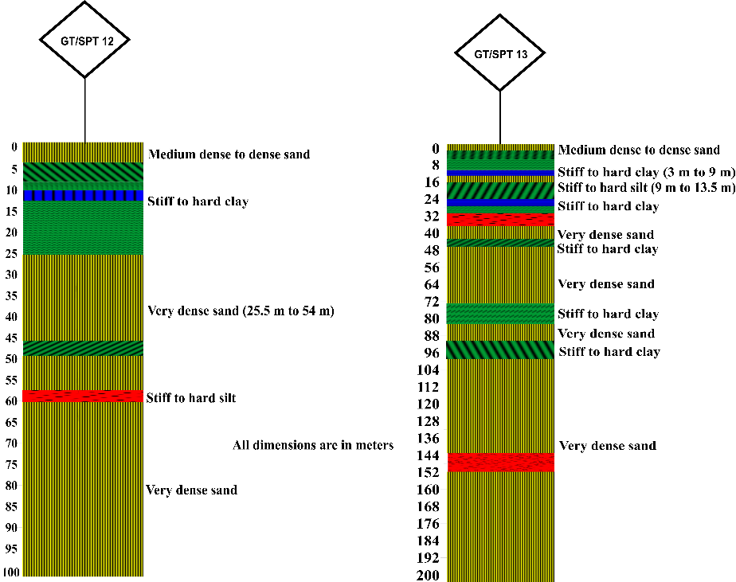
(b)
Figure 10.79 Sub-soil profile in Zone 6 as observed in a)T5, T6, GT-SPT14 b)GT-SPT12, GT-SPT13

Zone-7: Intertidal and Land Region at Dahej (Boreholes T7, T8, T9, L1, L2)
Detailed site investigation was carried out over the total length of this region at Dahej (referred to as Zone-7) to study the soil profile. The city of Dahej lies to the east of this zone which is bounded by Spillway Area on the west. A total of 5 boreholes constructed at frequent intervals formed an integral part of the site investigation. All the boreholes in this zone were constructed to a depth of about 15.50 m from Existing Ground Level (EGL).
As mentioned before, borehole T1 located in Intertidal region at Bhavnagar was assumed as a benchmark and the location marked the beginning (0.00 m) of the horizontal scale in the subsoil profile diagram. The location of subsequent boreholes in all the zones was determined with respect to the corresponding distance from T1. Accordingly, the location of borehole T7 is marked at 413.16 on the horizontal scale corresponding to a distance of 41315.75 m from borehole T1 on the true scale.

Borehole T7
The top section of the borehole (about 3.5 m with respect to EGL) composed of very soft to soft silty clay followed by layers of very loose silty fine sand and medium dense silty fine sand up to a depth of about 9 m. Layers of very stiff silty clay were observed beyond this depth.

Borehole T8
Soil layers in borehole T8 mainly comprised of very soft silty clay near the seabed to a depth of about 3.5 m from the EGL. Layers of medium dense silty fine sand with pockets of very loose silty sand were noted between a depth ranging between 3.5 m and 10.5 m from the EGL. Beyond this depth soil strata comprised of very stiff silty clay.

Borehole T9
Very soft to soft silty clay layers formed the top layers up to a depth of around 4.5 m from the EGL while the soil strata underneath were predominantly formed of stiff to very stiff silty clay stratum.

Borehole L1
Layers of stiff to very stiff silty clay extended from the EGL to a depth of about 3 m. A 3 m thick stratum of soft to very soft silty clay followed this layer up to a depth of around 6 m. Beyond this depth, the soil strata were largely composed of hard to very stiff silty clay layers.

Borehole L2
Medium stiff to stiff silty clay strata composed the top 1 m of the borehole underlain by layers of very soft to soft silty clay for the next 2 m depth. A very stiff silty clay layer together with pockets of stiff layers was encountered beyond this depth up to the bottom of the borehole. The subsoil profile strata in Zone 7 are shown in Figure 10.7.10.
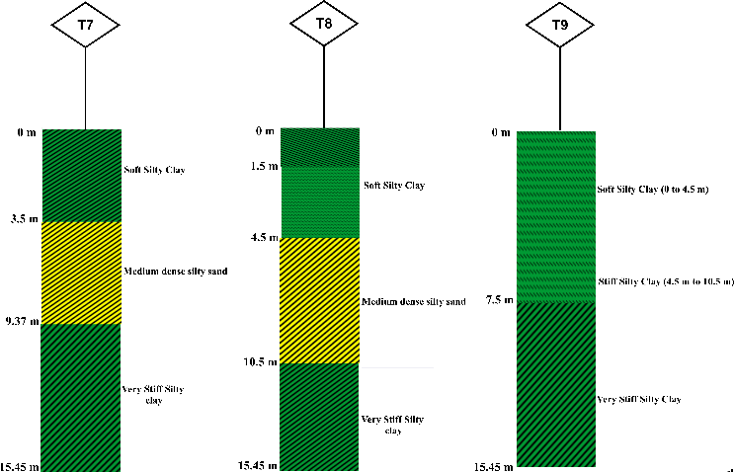
(a) | (b)
Figure 10.7.10 Subsoil profile strata of (a) T7, T8 and T9 (b) T9 (c) L1 and L2

10.7.2 Liquefaction Potential Assessment

(1) Introduction
The evaluation of liquefaction potential for the dam site is carried out using simplified semi-empirical procedures. The gulf region in the dam site is found to be comprised of loose to medium silty sands at the top level which can be prone to liquefaction in case of seismic activity. Because of this, a careful investigation of the liquefaction potential is carried out and discussed in this chapter. The methodology adopted for the liquefaction analysis is discussed in the beginning followed by results and discussions. A summary of the findings is given at the end.

(2) Methodology

(a) Procedure for liquefaction analysis as per Boulanger and Idriss (2014)
The liquefaction potential of cohesionless soils is evaluated using the semi-empirical procedures as per Boulanger and Idriss (2014). The results are then compared with that of simplified procedure as per IS 1893 (Part 1): 2016 and Eurocode 8 (Part 5): 2004. The evaluation procedure as per Boulanger and Idriss (2014) is explained below.
The factor of safety against liquefaction is defined as,
$$FS=\frac{CRR}{CSR}$$ | (10.1)
where CRR is the cyclic resistance ratio and CSR is the cyclic stress ratio.
The CSR is evaluated using the following equation,
$$CSR=0.65\left(\frac{a_{max}}{g}\right)\left(\frac{σ_{vo}}{{\acute{σ}}_{vo}}\right)r_{d}$$ | (10.2)
where, $a_{max}$ is the peak acceleration intensity (PGA), g is the acceleration due to gravity, $σ_{vo}$ is the total stress, ${\acute{σ}}_{vo}$ is the effective stress, $r_{d}$ is the stress reduction factor. The value of r_{d} is evaluated using the following relations.
$$\ln\left(r_{d}\right)=α\left(z\right)+β\left(z\right)M$$ | (10.3a)
$$α\left(z\right)=-1.012-1.126 \sin\left(\frac{z}{11.73}+5.133\right)$$ | (10.3b)
$$β\left(z\right)=0.10+0.118 \sin\left(\frac{z}{11.28}+5.142\right)$$ | (10.3c)
where z is depth in meters and M is the moment magnitude. The above equations are applicable up to a depth of 34 m.
The CRR is evaluated using the following equation.
$$CRR={CRR}_{7.5}\left(MSF\right)K_{σ}K_{α}$$ | (10.4)
It is customary to represent the values of CRR pertaining to earthquake ground motions generated by an earthquake having a moment magnitude of 7.5. In the above equation, CRR_{7.5} is the standard cyclic resistance ratio for a 7.5 magnitude earthquake obtained using values of SPT or CPT or shear wave velocity, $MSF$ is the magnitude scaling factor and $K_{σ}$ is the correction for high overburden pressure, and $K_{α}$ is correction for sloping ground. For non-sloping ground conditions, the value $K_{α}$ can be taken as unity. $MSF$ is evaluated using the following equation.
$$MSF=6.9 exp\left(\frac{-M}{4}\right)-0.058$$ | (10.5)
In the above equation, the value of $MSF$ is limited to 1.8 at smaller magnitudes ($M ≤5.25)$.
The value of $K_{σ}$ is evaluated using the following equation.
$$K_{σ}=1-C_{σ}\ln\left(\frac{{\acute{σ}}_{vo}}{P_{a}}\right) ≤1$$ | (10.6a)
$$C_{σ}=\frac{1}{18.9-2.55\sqrt{{\left(N_{1}\right)}_{60}}} ≤0.3$$ | (10.6b)

CRR_{7.5} using values of SPT
The ${CRR}_{7.5}$ in Eq. (3.4) is calculated using the following equation.
$${CRR}_{7.5}=exp\left(\frac{{{(N}_{1})}_{60cs}}{14.1}+{\left(\frac{{{(N}_{1})}_{60cs}}{126}\right)}^{2}\right)-{\left(\frac{{{(N}_{1})}_{60cs}}{23.6}\right)}^{3}+{\left(\frac{{{(N}_{1})}_{60cs}}{25.4}\right)}^{4}-2.8$$ | (10.7)
where, ${{(N}_{1})}_{60cs}$ is the corrected ${\left(N_{1}\right)}_{60}$ value for fines content. ${\left(N_{1}\right)}_{60}$ is the corrected $N_{60}$ value for overburden. $N_{60}$ is the SPT blow count for a hammer efficiency of 60 percent using a standardized equipment as per standards.
$N_{60}$ is evaluated using the following equation
$$N_{60}=C_{60}N$$ | (10.8)
where, $C_{60}$ is the correction factor corresponding to 60% hammer efficiency and non-standard type of equipment. The ${\left(N_{1}\right)}_{60}$ is calculated as
$${\left(N_{1}\right)}_{60}=C_{N}N_{60}$$ | (10.9)
where, $C_{N}$ is the correction factor for overburden, which is evaluated as,
$$C_{N}={\left(\frac{P_{a}}{{\acute{σ}}_{vo}}\right)}^{m}≤1.7$$ | (10.10a)
$$m=0.784-0.07687\sqrt{{\left(N_{1}\right)}_{60}}$$ | (10.10b)
where, $P_{a}$ is the atmospheric pressure.
Solving for $C_{N}$ requires iteration because $C_{N}$ and ${\left(N_{1}\right)}_{60}$ are dependent on each other. This iteration problem can be solved using the “iteration” option in excel or any other software.
The value of ${{(N}_{1})}_{60cs}$ is evaluated as
$${\left(N_{1}\right)}_{60CS}={\left(N_{1}\right)}_{60}+∆{\left(N_{1}\right)}_{60}$$ | (10.11a)
$$∆{\left(N_{1}\right)}_{60}=exp\left(1.63+\frac{9.7}{FC+0.1}-{\left(\frac{15.7}{FC+0.1}\right)}^{2}\right)$$ | (10.11b)
where $FC$ is the fines content.

(b) Simplified procedure for evaluation of liquefaction potential as per codal provisions
The simplified procedure given in IS 1893 (Part 1): 2016 is based upon Seed and Idriss (1971). The procedure as per Boulanger and Idriss (2014) is the modified version of the procedure as per Seed and Idriss (1971). In general, as per IS 1893 (Part 1): 2016, the framework evaluation procedure is same as that of the modified version barring changes in some relations. In particular, the relations for $r_{d}$, $MSF$, $K_{σ}$, $C_{N}$, ${\left(N_{1}\right)}_{60CS}$, and ${CRR}_{7.5}$ are different.
The liquefaction evaluation procedure as per Eurocode 8 (Part 5): 2004 is similar to IS 1893 (Part 1): 2016 with some differences with respect to procedure for normalization of SPT N value for overburden and energy efficiency and seismic shear stress. Further, it recommends usage of established empirical charts based on SPT blow count for simplified liquefaction analysis. Eurocode presented an empirical chart considering different fines content, but they are corresponding to an earthquake magnitude of 7.5. In the present investigation, the graphs have been modified by multiplying the ordinate values with a correction factor as mentioned in the code. A detailed explanation regarding the procedure can be found in IS 1893 (Part 1): 2016 and Eurocode 8 (Part 5): 2004, hence avoided here for brevity.

(C) Liquefaction potential assessment for cohesive soil
There are no established standard procedures for evaluating the liquefaction potential of fine grained and cohesive soils. The evaluation criteria used in the present investigation are listed in Table 10.7.1.
Table 10.7.1 Criteria for liquefaction assessment of fine grained and cohesive soils (Seed et al. 2003)
Non-liquefiable | Marginal | Liquefiable
Water content < 0.85 LL | Water content > 0.85 LL | Water content > 0.8 LL
LL > 47% | LL < 47% | LL < 37%
IP > 20% | IP < 20% | IP < 12%
Either of the above conditions should be satisfied | All the above conditions should be satisfied | All the above conditions should be satisfied

(3) Results
The results of liquefaction analysis considering maximum ground acceleration of 0.225g and 0.36 g are presented in Tables 10.7.2 and 10.7.3. Further, the results of liquefaction assessment as per Eurocode using empirical charts of SPT N values are presented in Tables 10.7.4 and 10.7.5.

Table 10.72 Results of the liquefaction analysis considering PGA = 0.225 g
Borehole No. | Depth (m | Soil type | SPT N value  (observed) | Cohesionless soil |  |  | Cohesive soil
 |  |  |  | Boulanger and Idriss (2014) | IS 1893 | Eurocode 8 | Remarks  (based on Seed et al. 2003)
 |  |  |  | FS | FS | FS | Remarks  (based on Seed et al. 2003)
Zone 1 – Intertidal region at Bhavnagar
T1 | 0.5 | CH | 2 | -- | -- | -- | Safe
T1 | 3 | CH | 2 | -- | -- | -- | Safe
T1 | 6 | CH | 1 | -- | -- | -- | Safe
T1 | 9 | CI | 9 | -- | -- | -- | Safe
T1 | 12 | CH | 9 | -- | -- | -- | Safe
T1 | 15 | CH | 11 | -- | -- | -- | Safe
T2 | 0.5 | MI | 2 | -- | -- | -- | Marginal
T2 | 3 | MH | 0 | -- | -- | -- | Safe
T2 | 6 | MI | 0 | -- | -- | -- | Marginal
T2 | 9 | CI | 0 | -- | -- | -- | Marginal
T2 | 12 | CI | 18 | -- | -- | -- | Safe
T2 | 15 | CH | 28 | -- | -- | -- | Safe
T3 | 0.5 | CI | 0 | -- | -- | -- | Safe
T3 | 3 | CI | 2 | -- | -- | -- | Safe
T3 | 6 | CI | 10 | -- | -- | -- | Safe
T3 | 9 | CL | 2 | -- | -- | -- | Marginal
T3 | 12 | CH | 11 | -- | -- | -- | Safe
T3 | 15 | CI | 14 | -- | -- | -- | Safe
T4 | 0.5 | SM | 16 | 1.05 | 1.48 | Safe | --
T4 | 3 | SM | 14 | 0.98 | 1.35 | Safe | --
T4 | 6 | SM | 16 | 1.06 | 1.43 | Safe | --
T4 | 9 | SM | 16 | 0.96 | 1.17 | Safe | --
T4 | 12 | SM | 24 | 1.43 | 1.90 | Safe | --
T4 | 15 | SM | 50 | Safe | Safe | Safe | --
GT-SPT2 | 1 | CI | 0 | -- | -- | -- | Safe
GT-SPT2 | 3 | CI | -- | -- | -- | -- | Marginal
GT-SPT2 | 6 | MI | 36 | -- | -- | -- | Data N/A
GT-SPT2 | 9 | MI | 19 | -- | -- | -- | Safe
GT-SPT2 | 12 | CH | 61 | -- | -- | -- | Safe
GT-SPT2 | 15 | CH | 51 | -- | -- | -- | Safe
GT-SPT2 | 18 | ML | 97 | -- | -- | -- | Safe
GT-SPT3 | 1 | SM | 7 | 0.56 | 0.67 | Liquefiable | --
GT-SPT3 | 3 | SM | 17 | 1.21 | 1.80 | Safe | --
GT-SPT3 | 6 | CH | 9 | -- | -- | -- | Safe
GT-SPT3 | 9 | CH | 15 | -- | -- | -- | Safe
GT-SPT3 | 12 | CH | 19 | -- | -- | -- | Safe
GT-SPT3 | 15 | CH | 23 | -- | -- | -- | Safe
GT-SPT3 | 18 | CH | 29 | -- | -- | -- | Data N/A
Zone 2 – Channel A in Gulf region
GT-SPT4 | 1 | SM | 7 | 0.56 | 0.63 | Liquefiable | --
GT-SPT4 | 3 | SM | 8 | 0.61 | 0.67 | Liquefiable | --
GT-SPT4 | 6 | SM | 10 | 0.69 | 0.74 | Liquefiable | --
GT-SPT4 | 9 | SM | 20 | 1.09 | 1.20 | Safe | --
GT-SPT4 | 12 | SM | 28 | 1.75 | 1.92 | Safe | --
GT-SPT4 | 15 | SM | 12 | 0.76 | 0.72 | Liquefiable | --
GT-SPT4 | 18 | SM | 16 | 0.96 | 0.99 | Liquefiable | --
GT-SPT5 | 1 | SM | 7 | 0.45 | 0.48 | Liquefiable | --
GT-SPT5 | 3 | SM | 8 | 0.66 | 0.82 | Liquefiable | --
GT-SPT5 | 6 | SM | 10 | 0.76 | 0.92 | Liquefiable | --
GT-SPT5 | 9 | SM | 25 | 1.63 | Safe | Safe | --
GT-SPT5 | 12 | SP-SM | 23 | 0.96 | 1.06 | Safe | --
GT-SPT5 | 15 | SP-SM | 17 | 0.74 | 0.70 | Liquefiable | --
GT-SPT5 | 18 | SP-SM | 16 | 0.80 | 0.74 | Liquefiable | --
Zone 3 – Channel B in Gulf region
GT-SPT6 | 1 | SP | 8 | 0.45 | 0.48 | Liquefiable | --
GT-SPT6 | 3 | SP-SM | 10 | 0.57 | 0.64 | Liquefiable | --
GT-SPT6 | 6 | SP-SM | 30 | 1.90 | 2.41 | Safe | --
GT-SPT6 | 9 | -- | 32 | 1.60 | 1.64 | Safe | --
GT-SPT6 | 12 | SP | 46 | 6.53 | Safe | Safe | --
GT-SPT6 | 15 | SP | R | Safe | Safe | Safe | --
GT-SPT6 | 18 | -- | 68
GT-SPT7 | 1 | SP | 10 | 0.56 | 0.62 | Liquefiable | --
GT-SPT7 | 3 | SM | 13 | 0.70 | 0.81 | Liquefiable | --
GT-SPT7 | 6 | SM | 16 | 1.04 | 1.28 | Safe | --
GT-SPT7 | 9 | SM | 13 | 0.77 | 0.80 | Liquefiable | --
GT-SPT7 | 12 | SM | 18 | 0.95 | 1.05 | Safe | --
GT-SPT7 | 15 | SM | 17 | 0.90 | 0.87 | Liquefiable | --
GT-SPT7 | 18 | SM | 26 | 1.26 | 1.23 | Safe | --
Zone 4 – Channel C in Gulf region
GT-SPT8 | 1.5 | SP | 16 | 0.76 | 0.92 | Safe | --
GT-SPT8 | 4.5 | SP | 35 | 3.31 | Safe | Safe | --
GT-SPT8 | 7.5 | SM | 32 | 4.79 | Safe | Safe | --
GT-SPT8 | 10.5 | SM | 35 | 3.32 | Safe | Safe | --
GT-SPT8 | 13.5 | SM | 37 | 4.20 | Safe | Safe | --
GT-SPT8 | 16.5 | SM | 42 | 4.58 | Safe | Safe | --
GT-SPT8 | 19.5 | SP-SM | 41 | 2.18 | 1.83 | Safe | --
GT-SPT9 | 1 | SP-SM | 18 | 1.10 | 1.66 | Safe | --
GT-SPT9 | 3 | SM | 34 | Safe | Safe | Safe | --
GT-SPT9 | 6 | SM | 16 | 1.06 | 1.46 | Safe | --
GT-SPT9 | 9 | SM | 21 | 1.21 | 1.41 | Safe | --
GT-SPT9 | 12 | SM | 23 | 1.37 | 1.81 | Safe | --
GT-SPT9 | 15 | SM | 54 | Safe | Safe | Safe | --
GT-SPT9 | 18 | SP-SM | 36 | 1.59 | 1.47 | Safe | --
Zone 5 – Channel D in Gulf region
GT-SPT10 | 1 | SM | 10 | 0.64 | 0.79 | Liquefiable | --
GT-SPT10 | 3 | SM | 16 | 1.08 | 1.45 | Safe | --
GT-SPT10 | 6 | SM | 48 | Safe | Safe | Safe | --
GT-SPT10 | 9 | SM | 56
GT-SPT10 | 12 | SM | 72
GT-SPT10 | 15 | SM | 56
GT-SPT10 | 18 | SM | 108
GT-SPT11 | 1.5 | SM | 22 | 1.77 | Safe | Safe | --
GT-SPT11 | 4.5 | SP-SM | 27 | 1.50 | Safe | Safe | --
GT-SPT11 | 7.5 | SM | 29 | 1.54 | Safe | Safe | --
GT-SPT11 | 10.5 | SM | 51 | Safe | Safe | Safe | --
GT-SPT11 | 13.5 | SP | 67
GT-SPT11 | 16.5 | -- | 74
GT-SPT11 | 19.5 | -- | 78
Zone 6 – Spillway area
GT-SPT12 | 1 | SM | 34 | Safe | Safe | Safe | --
GT-SPT12 | 3 | CH | 31 | -- | -- | -- | Data N/A
GT-SPT12 | 6 | CH | 36 | -- | -- | -- | Safe
GT-SPT12 | 9 | CI | 73 | -- | -- | -- | Data N/A
GT-SPT12 | 12 | CI | 84 | -- | -- | -- | Data N/A
GT-SPT12 | 15 | CI | 81 | -- | -- | -- | Marginal
GT-SPT12 | 18 | CI | 75 | -- | -- | -- | Data N/A
GT-SPT13 | 1.5 | SM | 13 | 0.81 | 1.11 | Safe | ---
GT-SPT13 | 4.5 | CI | 35 | -- | -- | -- | Safe
GT-SPT13 | 7.5 | CI | 81 | -- | -- | -- | Safe
GT-SPT13 | 10.5 | MI | 91 | -- | -- | -- | Marginal
GT-SPT13 | 13.5 | SM | 44 | Safe | Safe | Safe | --
GT-SPT13 | 16.5 | CI | 39 | -- | -- | -- | Safe
GT-SPT13 | 19.5 | CH | 62 | -- | -- | -- | Safe
GT-SPT14 | 1 | SM | 16 | 0.99 | 1.41 | Safe | --
GT-SPT14 | 3 | CH | 16 | -- | -- | -- | Data N/A
GT-SPT14 | 6 | CH | 32 | -- | -- | -- | Safe
GT-SPT14 | 9 | CH | 62 | -- | -- | -- | Safe
GT-SPT14 | 12 | CH | 46 | -- | -- | -- | Safe
GT-SPT14 | 15 | CH | 67 | -- | -- | -- | Safe
GT-SPT14 | 18 | CH | 74 | -- | -- | -- | Safe
T5 | 1 | SM | 9 | 0.64 | 0.82 | Liquefiable | --
T5 | 3 | CH | 11 | -- | -- | -- | Data N/A
T5 | 6 | CH | 25 | -- | -- | -- | Safe
T5 | 9 | CH | 39 | -- | -- | -- | Safe
T5 | 12 | CH | 42 | -- | -- | -- | Safe
T5 | 15 | CH | 47 | -- | -- | -- | Data N/A
T6 | 1 | SM | 11 | 0.53 | 0.61 | Liquefiable | --
T6 | 3 | CH | 14 | -- | -- | -- | Data N/A
T6 | 6 | CH | 31 | -- | -- | -- | Safe
T6 | 9 | CH | 43 | -- | -- | -- | Data N/A
T6 | 12 | CH | 47 | -- | -- | -- | Data N/A
T6 | 15 | CH | 53 | -- | -- | -- | Safe
Zone 7 – Intertidal & Land Region at Dahej
T7 | 1 | CH | 1 | -- | -- | -- | Safe
T7 | 3 | CH | 3 | -- | -- | -- | Safe
T7 | 6 | SM | 18 | 1.21 | 1.71 | Safe | --
T7 | 9 | SM | 21 | 1.27 | 1.72 | Safe | --
T7 | 12 | CH | 22 | -- | -- | -- | Safe
T7 | 15 | CH | 24 | -- | -- | -- | Safe
T8 | 1 | CH | 2 | -- | -- | -- | Safe
T8 | 3 | CI | 3 | -- | -- | -- | Safe
T8 | 6 | SM | 21 | 1.70 | safe | Safe | --
T8 | 9 | SM | 11 | 0.73 | 0.84 | Liquefiable | --
T8 | 12 | CH | 19 | -- | -- | -- | Safe
T8 | 15 | CH | 22 | -- | -- | -- | Safe
T9 | 1 | CI | 2 | -- | -- | -- | Marginal
T9 | 3 | CI | 1 | -- | -- | -- | Safe
T9 | 6 | CI | 5 | -- | -- | -- | Marginal
T9 | 9 | CH | 11 | -- | -- | -- | Safe
T9 | 12 | CH | 25 | -- | -- | -- | Safe
T9 | 15 | CH | 24 | -- | -- | -- | Safe
L1 | 1 | CH | 14 | -- | -- | -- | Safe
L1 | 3 | CH | 3 | -- | -- | -- | Safe
L1 | 6 | CH | 26 | -- | -- | -- | Safe
L1 | 9 | CI | 26 | -- | -- | -- | Safe
L1 | 12 | CI | 26 | -- | -- | -- | Safe
L1 | 15 | CI | 39 | -- | -- | -- | Safe
L2 | 1 | CH | 5 | -- | -- | -- | Data N/A
L2 | 3 | CH | 12 | -- | -- | -- | Safe
L2 | 6 | CH | 5 | -- | -- | -- | Safe
L2 | 9 | CI | 10 | -- | -- | -- | Safe
L2 | 12 | CI | 12 | -- | -- | -- | Marginal
L2 | 15 | CI | 25 | -- | -- | -- | Data N/A

Table 10.73 Results of the liquefaction analysis considering PGA = 0.36g
Borehole No. | Depth (m | Soil type | SPT N value  (observed) | Cohesionless soil |  |  | Cohesive soil
 |  |  |  | Boulanger and Idriss (2014) | IS 1893 | Eurocode 8 | Remarks  (based on Seed et al. 2003)
 |  |  |  | FS | FS | FS | Remarks  (based on Seed et al. 2003)
Zone 1 – Intertidal region at Bhavnagar
T1 | 0.5 | CH | 2 | -- | -- | -- | Safe
T1 | 3 | CH | 2 | -- | -- | -- | Safe
T1 | 6 | CH | 1 | -- | -- | -- | Safe
T1 | 9 | CI | 9 | -- | -- | -- | Safe
T1 | 12 | CH | 9 | -- | -- | -- | Safe
T1 | 15 | CH | 11 | -- | -- | -- | Safe
T2 | 0.5 | MI | 2 | -- | -- | -- | Marginal
T2 | 3 | MH | 0 | -- | -- | -- | Safe
T2 | 6 | MI | 0 | -- | -- | -- | Marginal
T2 | 9 | CI | 0 | -- | -- | -- | Marginal
T2 | 12 | CI | 18 | -- | -- | -- | Safe
T2 | 15 | CH | 28 | -- | -- | -- | Safe
T3 | 0.5 | CI | 0 | -- | -- | -- | Safe
T3 | 3 | CI | 2 | -- | -- | -- | Safe
T3 | 6 | CI | 10 | -- | -- | -- | Safe
T3 | 9 | CL | 2 | -- | -- | -- | Marginal
T3 | 12 | CH | 11 | -- | -- | -- | Safe
T3 | 15 | CI | 14 | -- | -- | -- | Safe
T4 | 0.5 | SM | 16 | 0.68 | 0.96 | Safe | --
T4 | 3 | SM | 14 | 0.64 | 0.88 | Liquefiable | --
T4 | 6 | SM | 16 | 0.69 | 0.93 | Liquefiable | --
T4 | 9 | SM | 16 | 0.63 | 0.76 | Liquefiable | --
T4 | 12 | SM | 24 | 0.93 | 1.23 | Liquefiable | --
T4 | 15 | SM | 50 | Safe | Safe | Safe | --
GT-SPT2 | 1 | CI | 0 | -- | -- | -- | Safe
GT-SPT2 | 3 | CI | -- | -- | -- | -- | Marginal
GT-SPT2 | 6 | MI | 36 | -- | -- | -- | Data N/A
GT-SPT2 | 9 | MI | 19 | -- | -- | -- | Liquefiable
GT-SPT2 | 12 | CH | 61 | -- | -- | -- | Safe
GT-SPT2 | 15 | CH | 51 | -- | -- | -- | Safe
GT-SPT2 | 18 | ML | 97 | -- | -- | -- | Safe
GT-SPT3 | 1 | SM | 7 | 0.36 | 0.43 | Liquefiable | --
GT-SPT3 | 3 | SM | 17 | 0.79 | 1.17 | Safe | --
GT-SPT3 | 6 | CH | 9 | -- | -- | -- | Safe
GT-SPT3 | 9 | CH | 15 | -- | -- | -- | Safe
GT-SPT3 | 12 | CH | 19 | -- | -- | -- | Safe
GT-SPT3 | 15 | CH | 23 | -- | -- | -- | Safe
GT-SPT3 | 18 | CH | 29 | -- | -- | -- | Data N/A

Zone 2 – Channel A in Gulf region
GT-SPT4 | 1 | SM | 7 | 0.36 | 0.41 | Liquefiable | --
GT-SPT4 | 3 | SM | 8 | 0.39 | 0.44 | Liquefiable | --
GT-SPT4 | 6 | SM | 10 | 0.45 | 0.48 | Liquefiable | --
GT-SPT4 | 9 | SM | 20 | 0.71 | 0.78 | Liquefiable | --
GT-SPT4 | 12 | SM | 28 | 1.13 | 1.25 | Safe | --
GT-SPT4 | 15 | SM | 12 | 0.50 | 0.47 | Liquefiable | --
GT-SPT4 | 18 | SM | 16 | 0.62 | 0.64 | Liquefiable | --
GT-SPT5 | 1 | SM | 7 | 0.30 | 0.31 | Liquefiable | --
GT-SPT5 | 3 | SM | 8 | 0.43 | 0.53 | Liquefiable | --
GT-SPT5 | 6 | SM | 10 | 0.49 | 0.60 | Liquefiable | --
GT-SPT5 | 9 | SM | 25 | 1.06 | 1.39 | Safe | --
GT-SPT5 | 12 | SP-SM | 23 | 0.63 | 0.69 | Liquefiable | --
GT-SPT5 | 15 | SP-SM | 17 | 0.48 | 0.46 | Liquefiable | --
GT-SPT5 | 18 | SP-SM | 16 | 0.52 | 0.48 | Liquefiable | --
Zone 3 – Channel B in Gulf region
GT-SPT6 | 1 | SP | 8 | 0.30 | 0.31 | Liquefiable | --
GT-SPT6 | 3 | SP-SM | 10 | 0.37 | 0.42 | Liquefiable | --
GT-SPT6 | 6 | SP-SM | 30 | 1.23 | 1.57 | Safe | --
GT-SPT6 | 9 | -- | 32 | 1.05 | 1.09 | Safe | --
GT-SPT6 | 12 | SP | 46 | Safe | Safe | Safe | --
GT-SPT6 | 15 | SP | R
GT-SPT6 | 18 | -- | 68
GT-SPT7 | 1 | SP | 10 | 0.36 | 0.41 | Liquefiable | --
GT-SPT7 | 3 | SM | 13 | 0.61 | 0.77 | Liquefiable | --
GT-SPT7 | 6 | SM | 16 | 0.67 | 0.83 | Liquefiable | --
GT-SPT7 | 9 | SM | 13 | 0.54 | 0.60 | Liquefiable | --
GT-SPT7 | 12 | SM | 18 | 0.62 | 0.68 | Liquefiable | --
GT-SPT7 | 15 | SM | 17 | 0.59 | 0.57 | Liquefiable | --
GT-SPT7 | 18 | SM | 26 | 0.82 | 0.80 | Liquefiable | --
Zone 4 – Channel C in Gulf region
GT-SPT8 | 1.5 | SP | 16 | 0.50 | 0.59 | Safe | --
GT-SPT8 | 4.5 | SP | 35 | 2.15 | Safe | Safe | --
GT-SPT8 | 7.5 | SM | 32 | 3.11 | Safe | Safe | --
GT-SPT8 | 10.5 | SM | 35 | 2.16 | Safe | Safe | --
GT-SPT8 | 13.5 | SM | 37 | 2.73 | Safe | Safe | --
GT-SPT8 | 16.5 | SM | 42 | 2.98 | Safe | Safe | --
GT-SPT8 | 19.5 | SP-SM | 41 | 1.42 | 1.19 | Safe | --
GT-SPT9 | 1 | SP-SM | 18 | 0.72 | 1.08 | Safe | --
GT-SPT9 | 3 | SM | 34 | Safe | Safe | Safe | --
GT-SPT9 | 6 | SM | 16 | 0.69 | 0.95 | Liquefiable | --
GT-SPT9 | 9 | SM | 21 | 0.79 | 0.92 | Liquefiable | --
GT-SPT9 | 12 | SM | 23 | 0.89 | 1.17 | Safe | --
GT-SPT9 | 15 | SM | 54 | Safe | Safe | Safe | --
GT-SPT9 | 18 | SP-SM | 36 | 1.03 | 0.96 | Safe | --
Zone 5 – Channel D in Gulf region
GT-SPT10 | 1 | SM | 10 | 0.42 | 0.52 | Liquefiable | --
GT-SPT10 | 3 | SM | 16 | 0.70 | 0.94 | Marginal | --
GT-SPT10 | 6 | SM | 48 | Safe | Safe | Safe | --
GT-SPT10 | 9 | SM | 56
GT-SPT10 | 12 | SM | 72
GT-SPT10 | 15 | SM | 56
GT-SPT10 | 18 | SM | 108
GT-SPT11 | 1.5 | SM | 22 | 1.15 | Safe | Safe | --
GT-SPT11 | 4.5 | SP-SM | 27 | 0.98 | Safe | Safe | --
GT-SPT11 | 7.5 | SM | 29 | 1.97 | Safe | Safe | --
GT-SPT11 | 10.5 | SM | 51 | Safe | Safe | Safe | --
GT-SPT11 | 13.5 | SP | 67
GT-SPT11 | 16.5 | -- | 74
GT-SPT11 | 19.5 | -- | 78
Zone 6 – Spillway area
GT-SPT12 | 1 | SM | 34 | Safe | Safe | Safe | --
GT-SPT12 | 3 | CH | 31 | -- | -- | -- | Data N/A
GT-SPT12 | 6 | CH | 36 | -- | -- | -- | Safe
GT-SPT12 | 9 | CI | 73 | -- | -- | -- | Data N/A
GT-SPT12 | 12 | CI | 84 | -- | -- | -- | Data N/A
GT-SPT12 | 15 | CI | 81 | -- | -- | -- | Safe
GT-SPT12 | 18 | CI | 75 | -- | -- | -- | Data N/A
GT-SPT13 | 1.5 | SM | 13 | 0.53 | 0.72 | Liquefiable | ---
GT-SPT13 | 4.5 | CI | 35 | -- | -- | -- | Safe
GT-SPT13 | 7.5 | CI | 81 | -- | -- | -- | Safe
GT-SPT13 | 10.5 | MI | 91 | -- | -- | -- | Safe
GT-SPT13 | 13.5 | SM | 44 | Safe | Safe | Safe | --
GT-SPT13 | 16.5 | CI | 39 | -- | -- | -- | Safe
GT-SPT13 | 19.5 | CH | 62 | -- | -- | -- | Safe
GT-SPT14 | 1 | SM | 16 | 0.64 | 0.91 | Safe | --
GT-SPT14 | 3 | CH | 16 | -- | -- | -- | Data N/A
GT-SPT14 | 6 | CH | 32 | -- | -- | -- | Safe
GT-SPT14 | 9 | CH | 62 | -- | -- | -- | Safe
GT-SPT14 | 12 | CH | 46 | -- | -- | -- | Safe
GT-SPT14 | 15 | CH | 67 | -- | -- | -- | Safe
GT-SPT14 | 18 | CH | 74 | -- | -- | -- | Safe
T5 | 1 | SM | 9 | 0.42 | 0.53 | Liquefiable | --
T5 | 3 | CH | 11 | -- | -- | -- | Data N/A
T5 | 6 | CH | 25 | -- | -- | -- | Safe
T5 | 9 | CH | 39 | -- | -- | -- | Safe
T5 | 12 | CH | 42 | -- | -- | -- | Safe
T5 | 15 | CH | 47 | -- | -- | -- | Data N/A
T6 | 1 | SM | 11 | 0.35 | 0.40 | Liquefiable | --
T6 | 3 | CH | 14 | -- | -- | -- | Data N/A
T6 | 6 | CH | 31 | -- | -- | -- | Safe
T6 | 9 | CH | 43 | -- | -- | -- | Data N/A
T6 | 12 | CH | 47 | -- | -- | -- | Data N/A
T6 | 15 | CH | 53 | -- | -- | -- | Safe
Zone 7 – Intertidal & Land Region at Dahej
T7 | 1 | CH | 1 | -- | -- | -- | Safe
T7 | 3 | CH | 3 | -- | -- | -- | Safe
T7 | 6 | SM | 18 | 0.78 | 1.11 | Liquefiable | --
T7 | 9 | SM | 21 | 0.83 | 1.12 | Marginal | --
T7 | 12 | CH | 22 | -- | -- | -- | Safe
T7 | 15 | CH | 24 | -- | -- | -- | Safe
T8 | 1 | CH | 2 | -- | -- | -- | Safe
T8 | 3 | CI | 3 | -- | -- | -- | Safe
T8 | 6 | SM | 21 | 1.11 | safe | Safe | --
T8 | 9 | SM | 11 | 0.47 | 0.54 | Liquefiable | --
T8 | 12 | CH | 19 | -- | -- | -- | Safe
T8 | 15 | CH | 22 | -- | -- | -- | Safe
T9 | 1 | CI | 2 | -- | -- | -- | Marginal
T9 | 3 | CI | 1 | -- | -- | -- | Safe
T9 | 6 | CI | 5 | -- | -- | -- | Marginal
T9 | 9 | CH | 11 | -- | -- | -- | Safe
T9 | 12 | CH | 25 | -- | -- | -- | Safe
T9 | 15 | CH | 24 | -- | -- | -- | Safe
L1 | 1 | CH | 14 | -- | -- | -- | Safe
L1 | 3 | CH | 3 | -- | -- | -- | Safe
L1 | 6 | CH | 26 | -- | -- | -- | Safe
L1 | 9 | CI | 26 | -- | -- | -- | Safe
L1 | 12 | CI | 26 | -- | -- | -- | Safe
L1 | 15 | CI | 39 | -- | -- | -- | Safe
L2 | 1 | CH | 5 | -- | -- | -- | Data N/A
L2 | 3 | CH | 12 | -- | -- | -- | Safe
L2 | 6 | CH | 5 | -- | -- | -- | Safe
L2 | 9 | CI | 10 | -- | -- | -- | Safe
L2 | 12 | CI | 12 | -- | -- | -- | Marginal
L2 | 15 | CI | 25 | -- | -- | -- | Data N/A

Table 10.74 Results of the liquefaction analysis as per Eurocode 8 (Part 5): 2004
PGA = 0.225 g
Zone 1 – Intertidal region at Bhavnagar
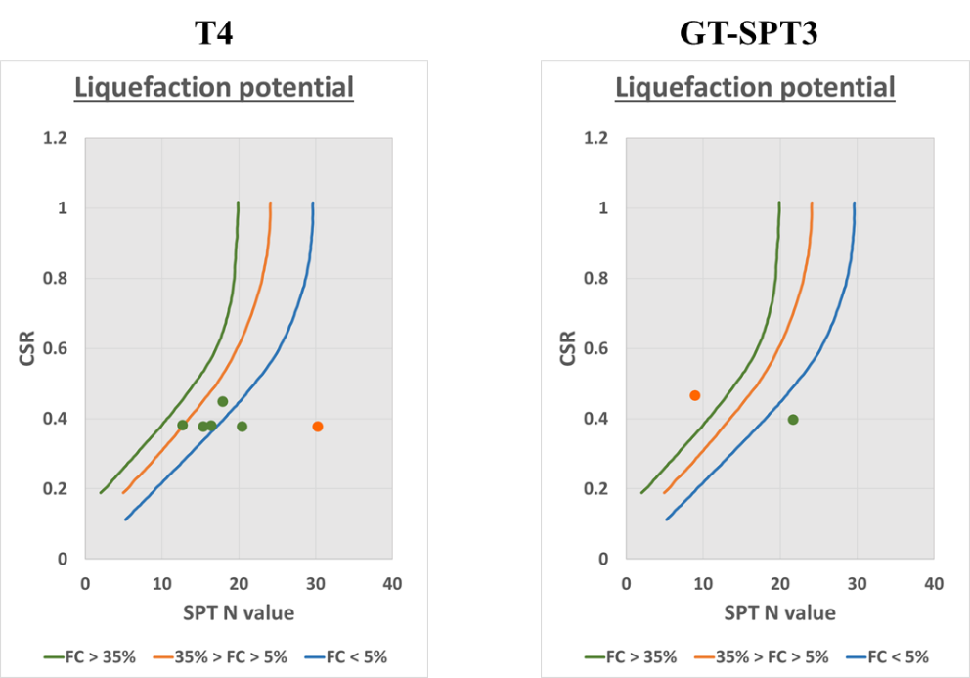
Zone 2 – Channel A in Gulf region
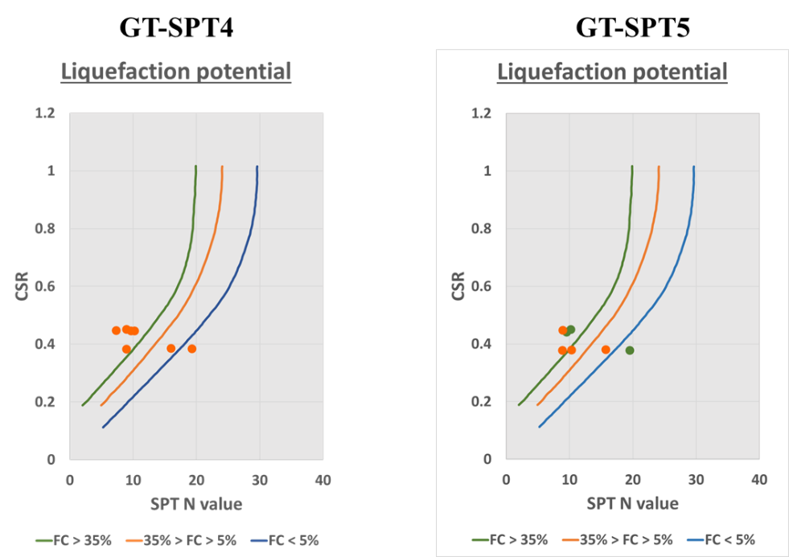

Zone 3 – Channel B in Gulf region
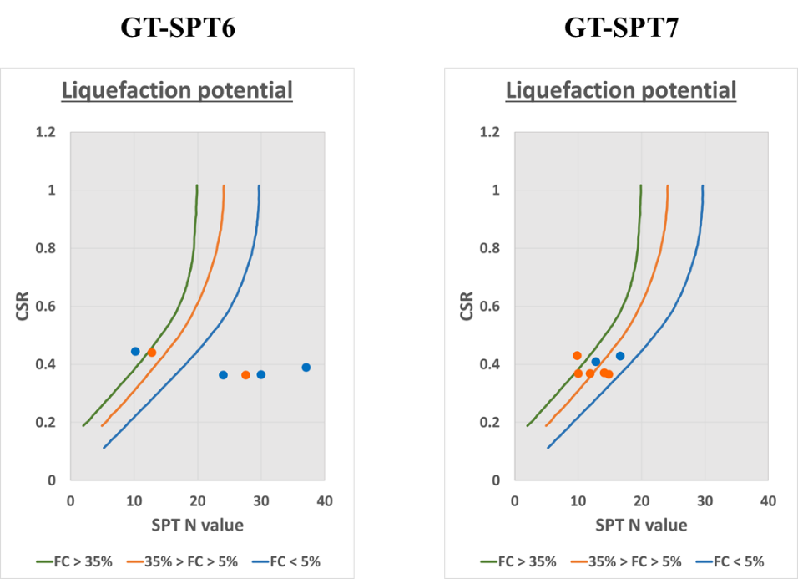
Zone 4 – Channel C in Gulf region
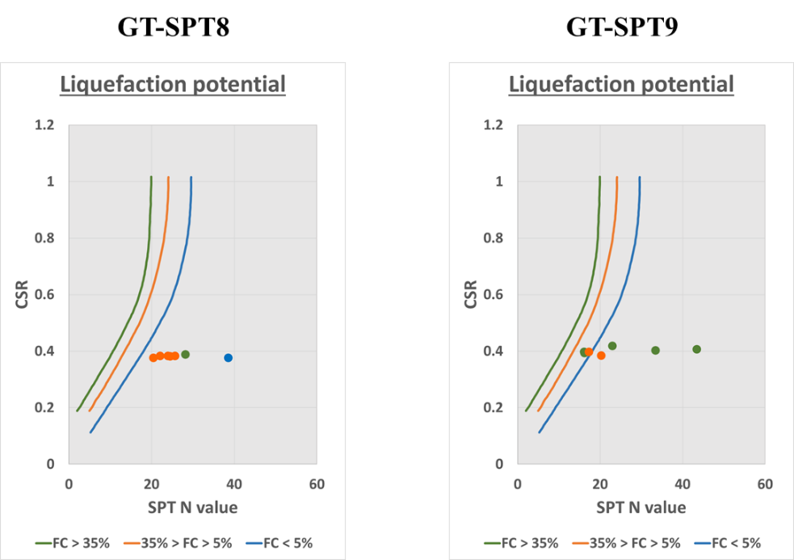

Zone 5 – Channel D in Gulf region
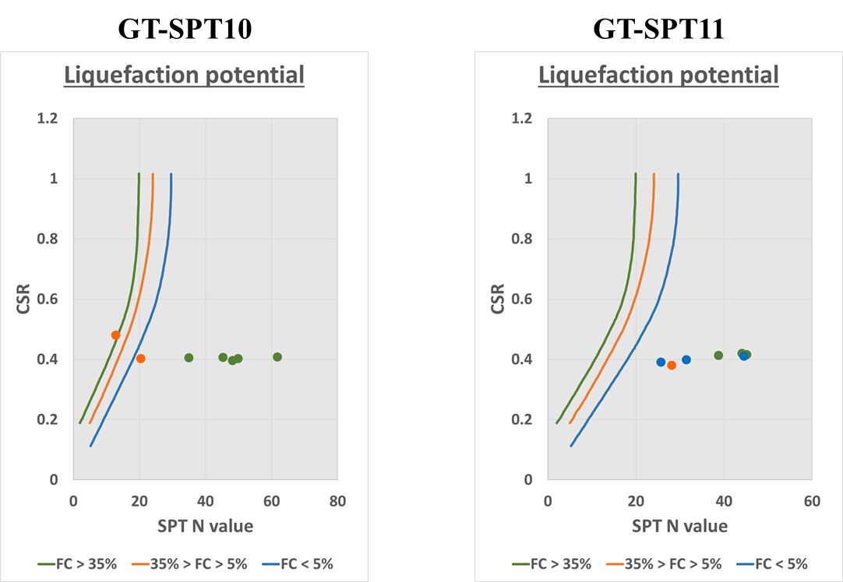
Zone 6 – Spillway area
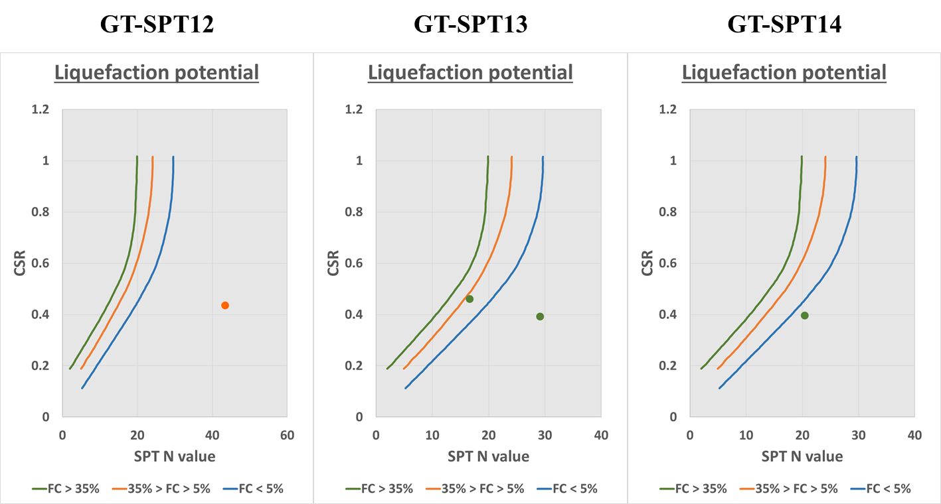
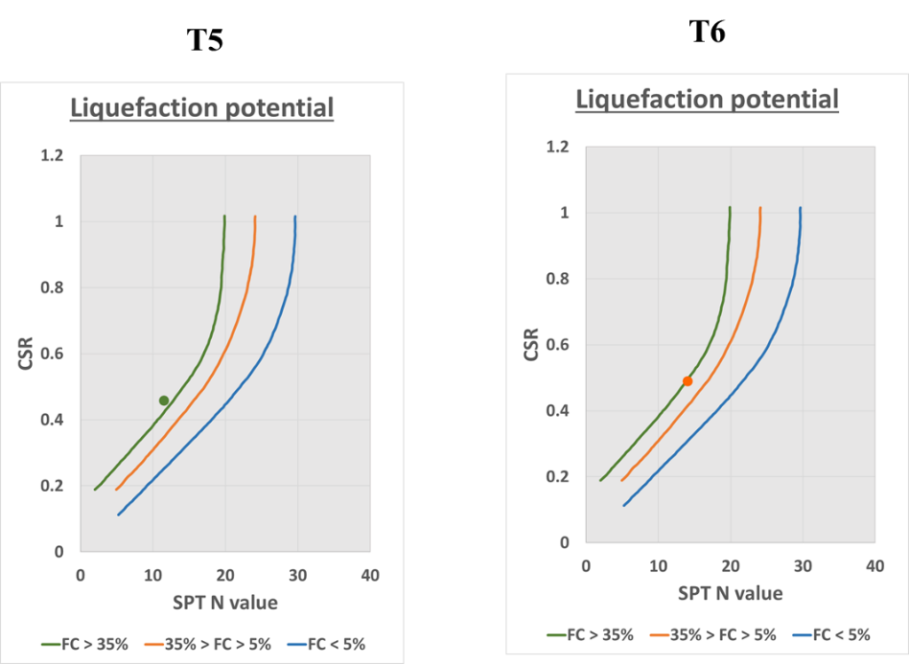
Zone 7 – Intertidal & Land Region at Dahej
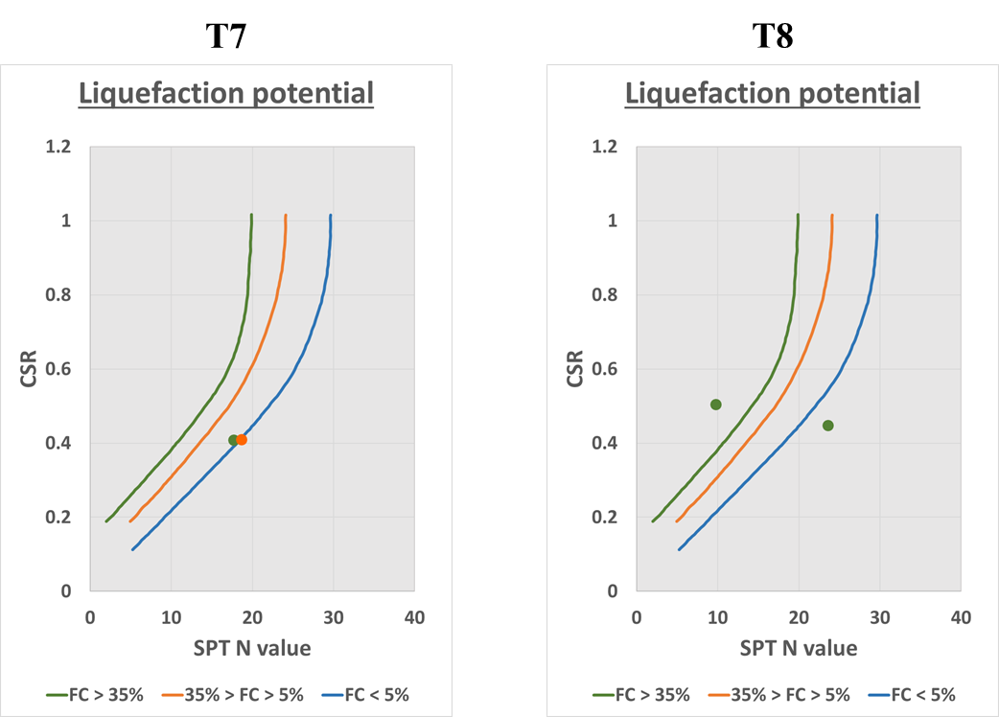

Table 10.75 Results of the Eurocode analysis (PGA = 0.36g)
PGA = 0.36g
Zone 1 – Intertidal region at Bhavnagar
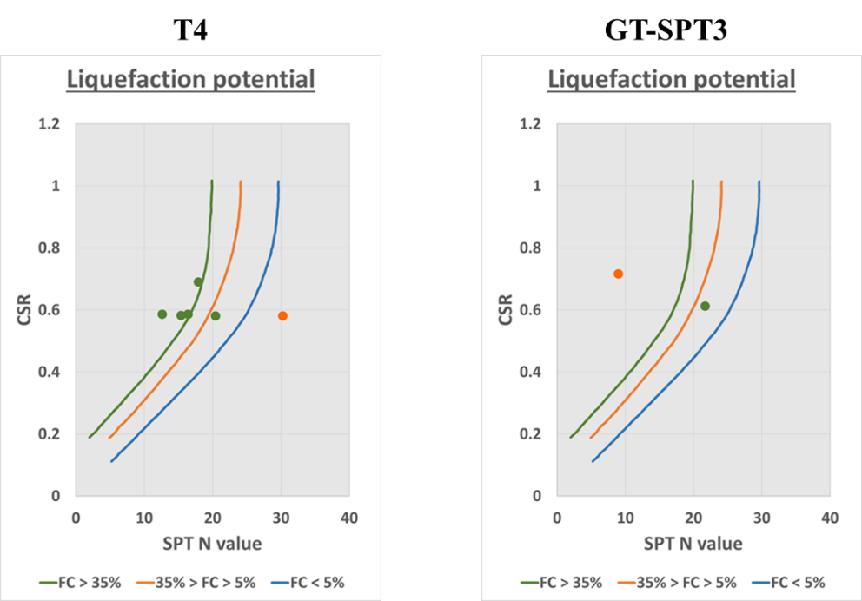
Zone 2 – Channel A in Gulf region
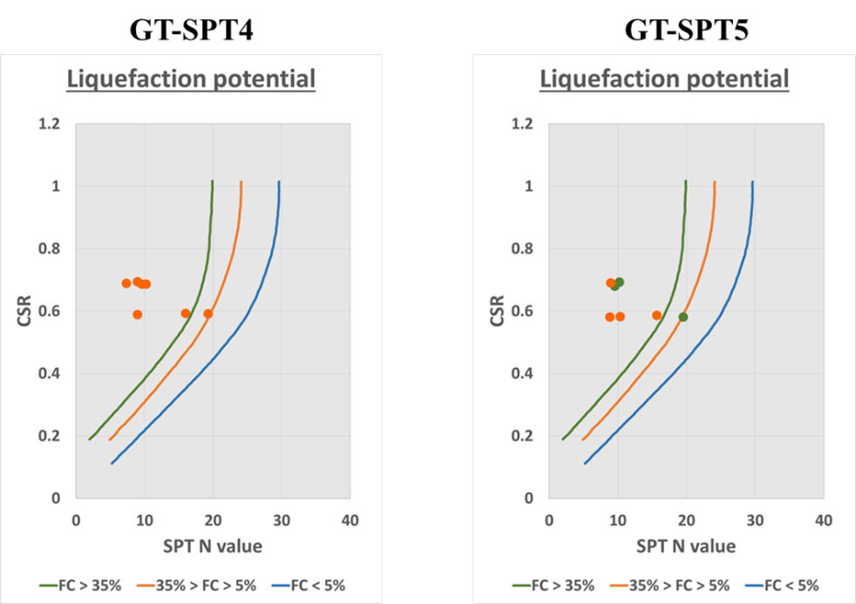

Zone 3 – Channel B in Gulf region
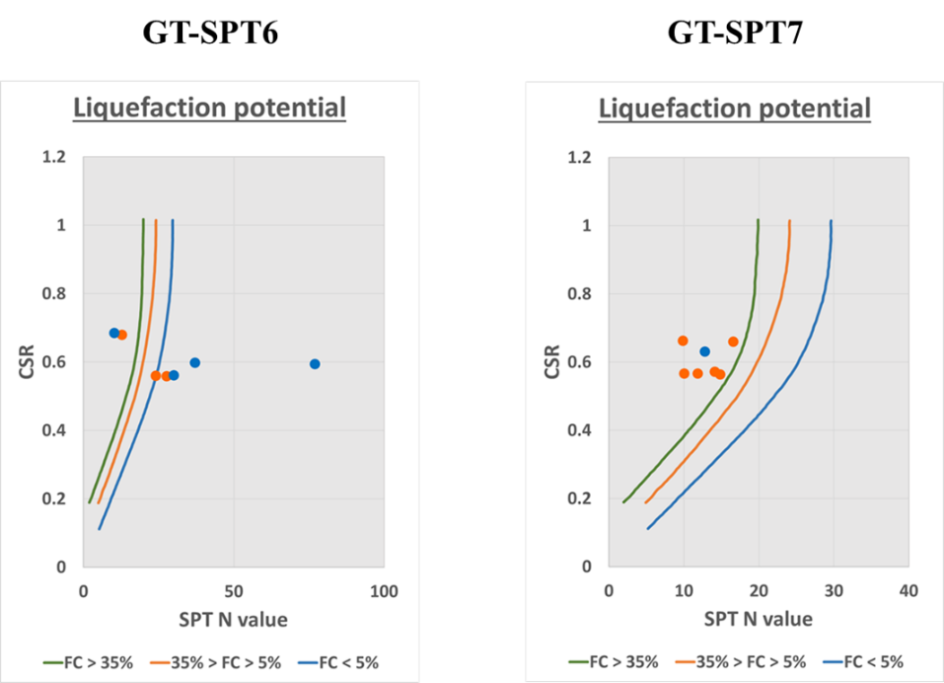
Zone 4 – Channel C in Gulf region
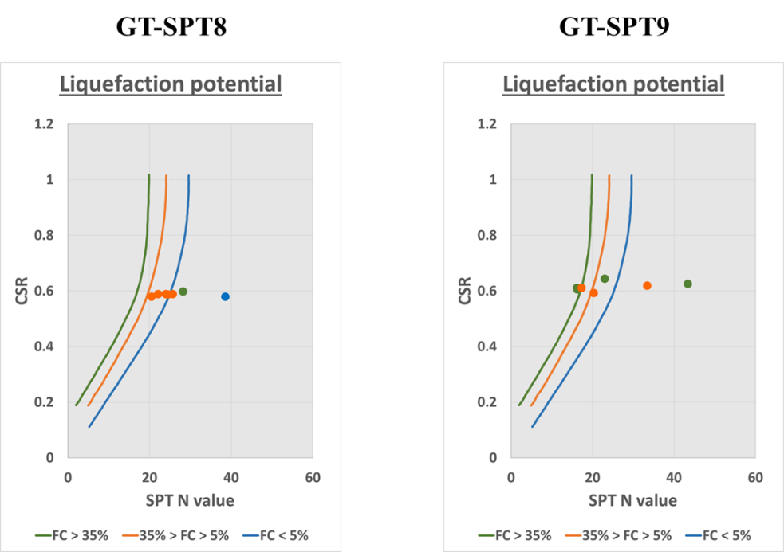

Zone 5 – Channel D in Gulf region
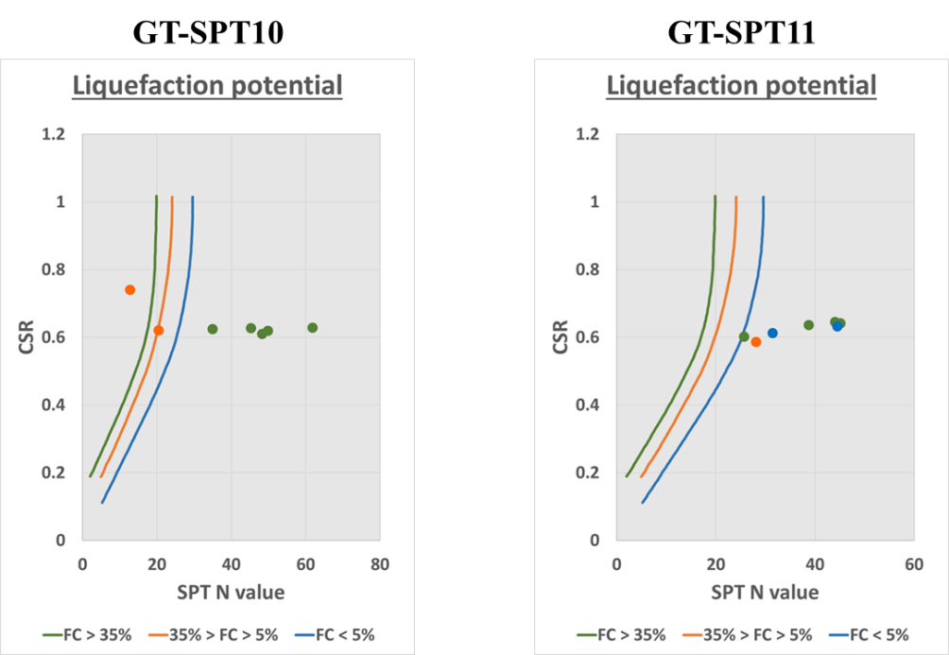
Zone 6 – Spillway area
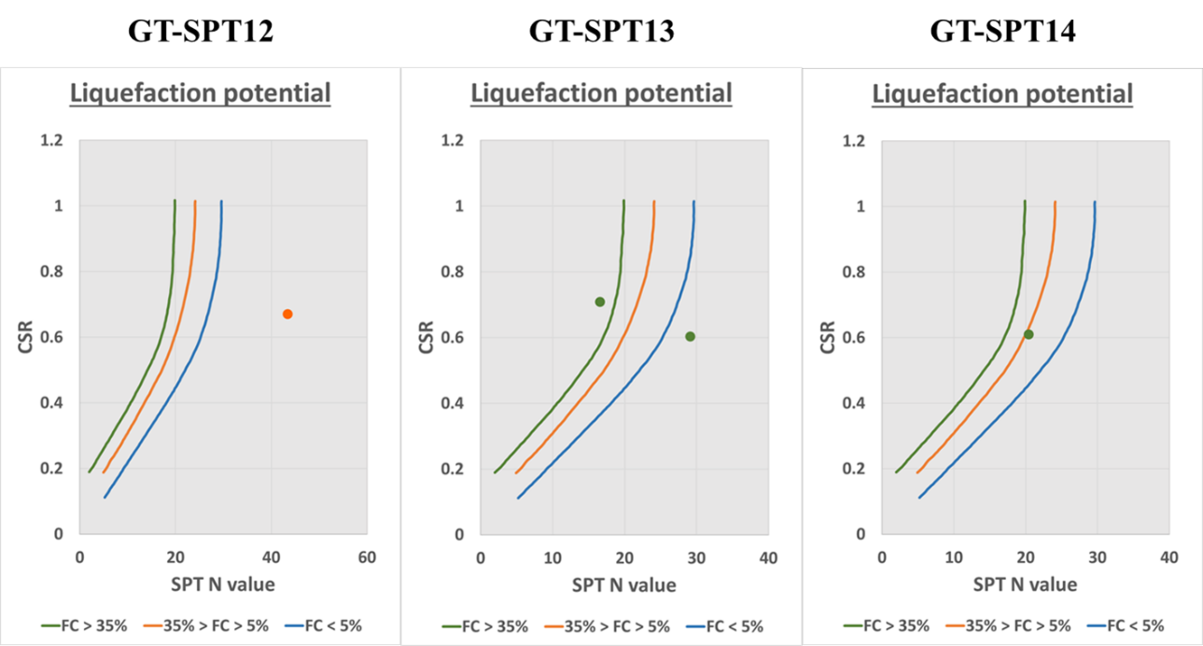

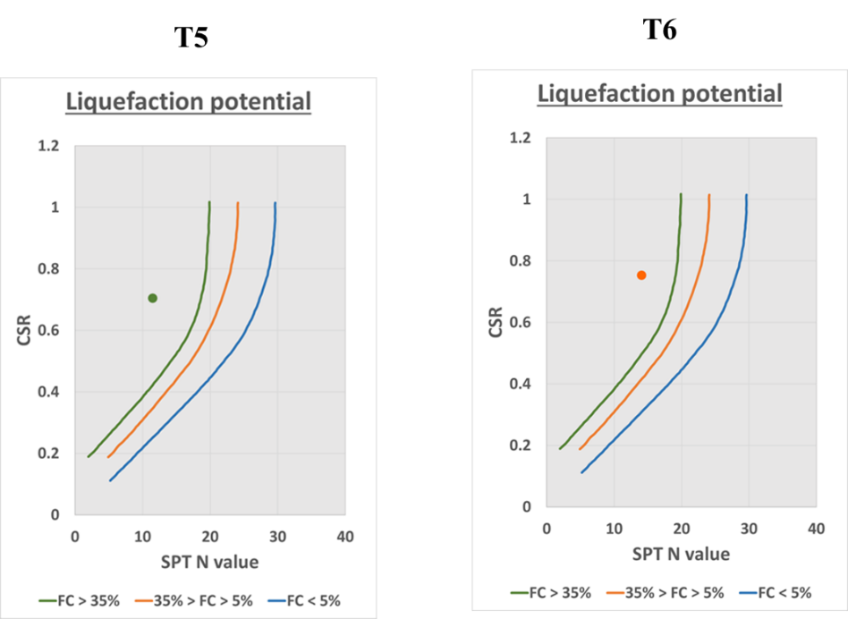
Zone 7 – Intertidal & Land Region at Dahej
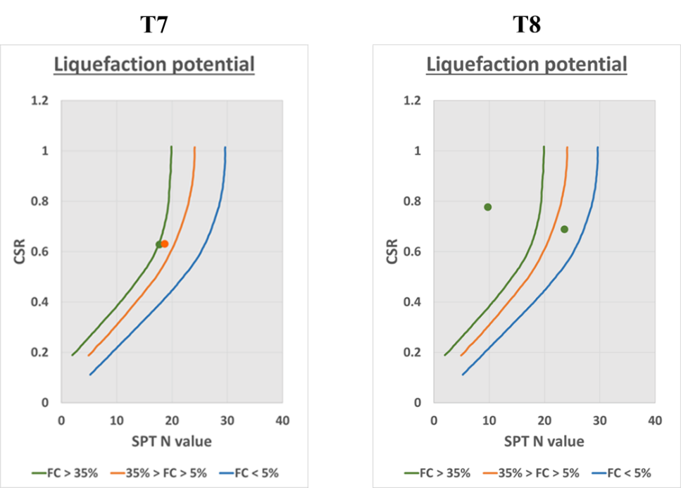

10.7.3 Discussion
The liquefaction potential assessment of cohesionless soil in dam site is carried out as per Boulanger and Idriss (2014). The results are also compared using procedures are given in IS 1893 (Part 1): 2016 and Eurocode 8 (Part 5): 2004. As there are no established procedures to evaluate liquefaction potential of cohesive soils, the assessment is carried out using criteria as per Seed et al. (2003). Based on the liquefaction assessment, it is found that soil in the boreholes in zones with predominant cohesive soils is safe against liquefaction under maximum ground acceleration of 0.225 g and 0.36 g and earthquake magnitude of 6.3. In case of boreholes with cohesionless soils, the soil in boreholes of zones with loose to medium dense sandy or silty sand soil is susceptible to liquefaction over the entire depth of assessment. In case of boreholes with medium dense to dense sandy or silty sand soil layers, the liquefaction susceptibility is seen up to 6 to 12 m and in some case up to 18 m for maximum ground acceleration of 0.225 g. However, for maximum ground acceleration of 0.36 g, the liquefaction susceptibility is seen up to entire depth of assessment, especially in Zone 2 and 3 of gulf region. A summary of the liquefaction analysis is presented in Table 10.76.
Table 10.76 Summary of liquefaction analysis
Borehole No. | Potentially liquefiable layers
Borehole No. | PGA = 0.225 g | PGA = 0.36 g
Zone 1 – Intertidal region at Bhavnagar
T1 | -- | --
T2 | -- | --
T3 | -- | --
T4 | 3-6 m, 9-12 m | 0.5-15 m
GT-SPT2 | -- | --
GT-SPT3 | 1-3 m | 1-6 m
Zone 2 – Channel A in Gulf region
GT-SPT4 | 1-9 m, 15-20 m | 1-12 m, 15-20 m
GT-SPT5 | 1-9 m, 12-20 m | 1-9 m, 12-20 m
Zone 3 – Channel B in Gulf region
GT-SPT6 | 1-6 m | 1-6 m
GT-SPT7 | 1-6 m, 9-18 m | 1-20 m
Zone 4 – Channel C in Gulf region
GT-SPT8 | 1-3 m | 1-3 m
GT-SPT9 | -- | 1-3 m, 6-15 m
Zone 5 – Channel D in Gulf region
GT-SPT10 | 1-3 m | 1-6 m
GT-SPT11 | -- | 4.5-7.5 m
Zone 6 – Spillway area
GT-SPT12 | -- | --
GT-SPT13 | 1.5-4.5 m | 1.5-4.5 m
GT-SPT14 | 1-3 m | 1-3 m
T5 | 1-3 m | 1-3 m
T6 | 1-3 m | 1-3 m
Zone 7 – Intertidal & Land Region at Dahej
T7 | --
T8 | 9-12 m | 6-12 m
T9 | -- | 9-12 m
L1 | -- | --
L2 | -- | --

(a) Liquefaction susceptibility for maximum ground acceleration of 0.225 g
The soil along the depth of liquefaction assessment i.e., 20 m in dam site across Zones 1, 6, and 7 consists predominantly of cohesive soils whereas Zones 2 to 5 consist of cohesionless soils. Based on the assessment, it is observed that, in Zone 1 (intertidal region at Bhavnagar), soil up to 20 m in boreholes T1, T2, T3, and GT-SPT2 is not susceptible to liquefaction. It is to be noted that the top 3 to 6 m in the above-mentioned boreholes consist of very soft to soft clayey soil. The borehole T4 in Zone 1 is reported to be consisting of silty sand soil up to 20 m and is found to be marginally susceptible up to 12 m. In borehole GT-SPT3 in Zone 1, the top 3 to 6 m is silty sand of which 1 to 3 m is found to be susceptible to liquefaction.
The soil in Zone 2 to 5 (gulf regions) is reported to be consisting of cohesion less up to 20 m. In Zone 2, the soil is found to be susceptible to liquefaction even at 20 m depth. In zone 3, in borehole GT-SPT6, the soil is liquefiable up to 6 m and in borehole GT-SPT7, the soil is liquefiable up to 18 m depth. In Zone 4 and 5, in boreholes GT-SPT8 and GT-SPT10, the top 3 m of the soil are liquefiable and in boreholes GT-SPT9 and GT-SPT11, the soil is found to be not susceptible to liquefaction.
In Zone 6 (spillway area), the soil consists predominantly of cohesive soil with top 1 to 3 m being medium dense to dense silty sand. The soil in the borehole GT-SPT12 is found to be safe against liquefaction. In boreholes GT-SPT13, GT-SPT14, T5, and T6, the top 1 to 3 are found to be liquefiable.
In Zone 7 (intertidal & Land Region at Dahej), the soil is predominantly clayey. The soil in boreholes T9, L1, and L2 is clayey soil of up to 20 m and is assessed to be safe against liquefaction. The soil in boreholes T7 and T8 consists predominantly of clayey soil with presence of silty sand from 6 to 12 m. It is found that, in borehole T8, the soil is susceptible to liquefaction from 9 to 12 m considering maximum ground acceleration of 0.225 g.

(b) Liquefaction susceptibility for maximum ground acceleration of 0.36 g
In Zone 1, the soil present in borehole T4 is susceptible to liquefaction up to 15 m. In borehole GT-SPT3, cohesionless soil layers (top 6 m) present is susceptible to liquefaction. In Zone 2, soil is found to be prone to liquefaction over the entire depth of liquefaction assessment i.e., 20 m. In Zone 3, soil in borehole GT-SPT6 is susceptible to liquefaction up to 3 to 6 m and in borehole GT-SPT6, soil is susceptible to liquefaction up to depth of assessment. In Zone 4, soil in borehole GT-SPT9 is susceptible to liquefaction up to 15 m. In Zone 5, soil in borehole GT-SPT11 is liquefiable up to 4.5 to 7.5 m. All the cohesionless soil layers (6 to 12 m) present in boreholes of Zone 7 are found to be susceptible to liquefaction. In the remaining boreholes across all the zones, the result is same as assessed for PGA of 0.225 g.
(c) Extent of ground improvement required
The factor of safety against liquefaction susceptibility depends on the SPT N value observed in the field. If the SPT N value of the existing ground is improved sufficiently enough to make the factor of safety greater than one, the soil becomes safe against liquefaction. Table 10.77 gives the SPT N values along the depth for all the boreholes for the soil to be non-liquefiable. It is observed that, for depth up to 10 m, the SPT N value of 25 ensures safety.
Table 10.77 SPT N value required for safety against liquefaction
Borehole No. | Depth (m | Soil type | SPT N value  (observed) | FS  (Boulanger and Idriss, 2014) |  | SPT N value  (Required for FS>1)
 |  |  |  | PGA = 0.225g | PGA = 0.36g | PGA = 0.225g | PGA = 0.36g
Zone 1 – Intertidal region at Bhavnagar
T4 | 0.5 | SM | 16 | 1.05 | 0.68 |  | 21
T4 | 3 | SM | 14 | 0.98 | 0.64 | 15 | 20
T4 | 6 | SM | 16 | 1.06 | 0.69 |  | 22
T4 | 9 | SM | 16 | 0.96 | 0.63 | 17 | 25
T4 | 12 | SM | 24 | 1.43 | 0.93 |  | 26
T4 | 15 | SM | 50 | Safe | Safe
GT-SPT3 | 1 | SM | 7 | 0.56 | 0.36 | 17 | 21
GT-SPT3 | 3 | SM | 17 | 1.21 | 0.79 |  | 20
Zone 2 – Channel A in Gulf region
GT-SPT4 | 1 | SM | 7 | 0.56 | 0.36 | 18 | 22
GT-SPT4 | 3 | SM | 8 | 0.61 | 0.39 | 16 | 23
GT-SPT4 | 6 | SM | 10 | 0.69 | 0.45 | 17 | 25
GT-SPT4 | 9 | SM | 20 | 1.09 | 0.71 |  | 29
GT-SPT4 | 12 | SM | 28 | 1.39 | 0.90 |  | 31
GT-SPT4 | 15 | SM | 12 | 0.76 | 0.50 | 20 | 33
GT-SPT4 | 18 | SM | 16 | 0.96 | 0.62 | 17 | 32
GT-SPT5 | 1 | SM | 7 | 0.45 | 0.30 | 20 | 25
GT-SPT5 | 3 | SM | 8 | 0.66 | 0.43 | 15 | 20
GT-SPT5 | 6 | SM | 10 | 0.76 | 0.49 | 15 | 22
GT-SPT5 | 9 | SM | 25 | 1.08 | 0.71 |  | 31
GT-SPT5 | 12 | SP-SM | 23 | 0.96 | 0.63 | 24 | 32
GT-SPT5 | 15 | SP-SM | 17 | 0.74 | 0.48 | 25 | 35
GT-SPT5 | 18 | SP-SM | 16 | 0.80 | 0.52 | 23 | 33
Zone 3 – Channel B in Gulf region
GT-SPT6 | 1 | SP | 8 | 0.45 | 0.30 | 21 | 26
GT-SPT6 | 3 | SP-SM | 10 | 0.57 | 0.37 | 20 | 26
GT-SPT6 | 6 | SP-SM | 30 | 1.90 | 1.23
GT-SPT6 | 9 | -- | 32 | 1.60 | 1.05
GT-SPT6 | 12 | SP | 46 | Safe | Safe
GT-SPT6 | 15 | SP | R | Safe | Safe
GT-SPT6 | 18 | -- | 68 | Safe | Safe
GT-SPT7 | 1 | SP | 10 | 0.56 | 0.36 | 20 | 25
GT-SPT7 | 3 | SM | 13 | 0.70 | 0.61 | 20 | 26
GT-SPT7 | 6 | SM | 16 | 1.04 | 0.67 |  | 22
GT-SPT7 | 9 | SM | 13 | 0.77 | 0.54 | 20 | 27
GT-SPT7 | 12 | SM | 18 | 0.95 | 0.62 | 20 | 28
GT-SPT7 | 15 | SM | 17 | 0.90 | 0.59 | 20 | 30
GT-SPT7 | 18 | SM | 26 | 1.26 | 0.82 |  | 31
Zone 4 – Channel C in Gulf region
GT-SPT8 | 1.5 | SP | 16 | 0.76 | 0.50 | 21 | 25
GT-SPT8 | 4.5 | SP | 35 | 3.31 | 2.15
GT-SPT8 | 7.5 | SM | 32 | 4.79 | 3.11
GT-SPT8 | 10.5 | SM | 35 | 3.32 | 2.16
GT-SPT8 | 13.5 | SM | 37 | 4.20 | 2.73
GT-SPT8 | 16.5 | SM | 42 | 4.58 | 2.98
GT-SPT8 | 19.5 | SP-SM | 41 | 2.18 | 1.42
GT-SPT9 | 1 | SP-SM | 18 | 1.10 | 0.72 |  | 22
GT-SPT9 | 3 | SM | 34 | Safe | Safe
GT-SPT9 | 6 | SM | 16 | 1.06 | 0.69 |  | 21
GT-SPT9 | 9 | SM | 21 | 1.21 | 0.79 |  | 25
GT-SPT9 | 12 | SM | 23 | 1.37 | 0.89 |  | 25
GT-SPT9 | 15 | SM | 54 | Safe | Safe
GT-SPT9 | 18 | SP-SM | 36 | 1.59 | 1.03
Zone 5 – Channel D in Gulf region
GT-SPT10 | 1 | SM | 10 | 0.64 | 0.42 | 17 | 22
GT-SPT10 | 3 | SM | 16 | 1.08 | 0.70 |  | 20
GT-SPT10 | 6 | SM | 48 | Safe | Safe
GT-SPT10 | 9 | SM | 56 | Safe | Safe
GT-SPT10 | 12 | SM | 72 | Safe | Safe
GT-SPT10 | 15 | SM | 56 | Safe | Safe
GT-SPT10 | 18 | SM | 108 | Safe | Safe
GT-SPT11 | 1.5 | SM | 22 | 1.77 | 1.15
GT-SPT11 | 4.5 | SP-SM | 27 | 1.50 | 0.98 |  | 28
GT-SPT11 | 7.5 | SM | 29 | 1.54 | 1.97
GT-SPT11 | 10.5 | SM | 51 | Safe | Safe
GT-SPT11 | 13.5 | SP | 67 | Safe | Safe
GT-SPT11 | 16.5 | -- | 74 | Safe | Safe
GT-SPT11 | 19.5 | -- | 78 | Safe | Safe
Zone 6 – Spillway area
GT-SPT12 | 1 | SM | 34 | Safe | Safe
GT-SPT13 | 1.5 | SM | 13 | 0.81 | 0.53 | 16 | 21
GT-SPT13 | 13.5 | SM | 44 | Safe | Safe
GT-SPT14 | 1 | SM | 16 | 0.99 | 0.64 | 17 | 21
T5 | 1 | SM | 9 | 0.64 | 0.42 | 16 | 21
T6 | 1 | SM | 11 | 0.53 | 0.35 | 21 | 26
Zone 7 – Intertidal & Land Region at Dahej
T7 | 6 | SM | 18 | 1.21 | 0.78 |  | 21
T7 | 9 | SM | 21 | 1.27 | 0.83 |  | 24
T8 | 6 | SM | 21 | 1.70 | 1.11
T8 | 9 | SM | 11 | 0.73 | 0.47 | 18 | 24

